Hello,

**Must do to submit**

**1. Maps**

I redid the maps to look nicer. If you would like to download them directly you can access them at

<https://www.dropbox.com/sh/8y8gyubwcln6uia/AAA_d1YU2dXN_1p6AmE6iIUNa?dl=0>.

You can find the code used to make the maps at

<https://github.com/jacobgellman/grassland_afforestation>.

Also, the legend on the current manuscript’ maps (Figure 1) is incomplete. I think the legend was taken from the map in panels A or B, but it doesn’t cover the full range of colors in C. In any event, the maps I provided at the above links are much better.

**2. Acreage figures**

The 118.4 million acres figure comes from [Nielsen et al. (2014)](https://www.fs.usda.gov/treesearch/pubs/45563), reproduced below.

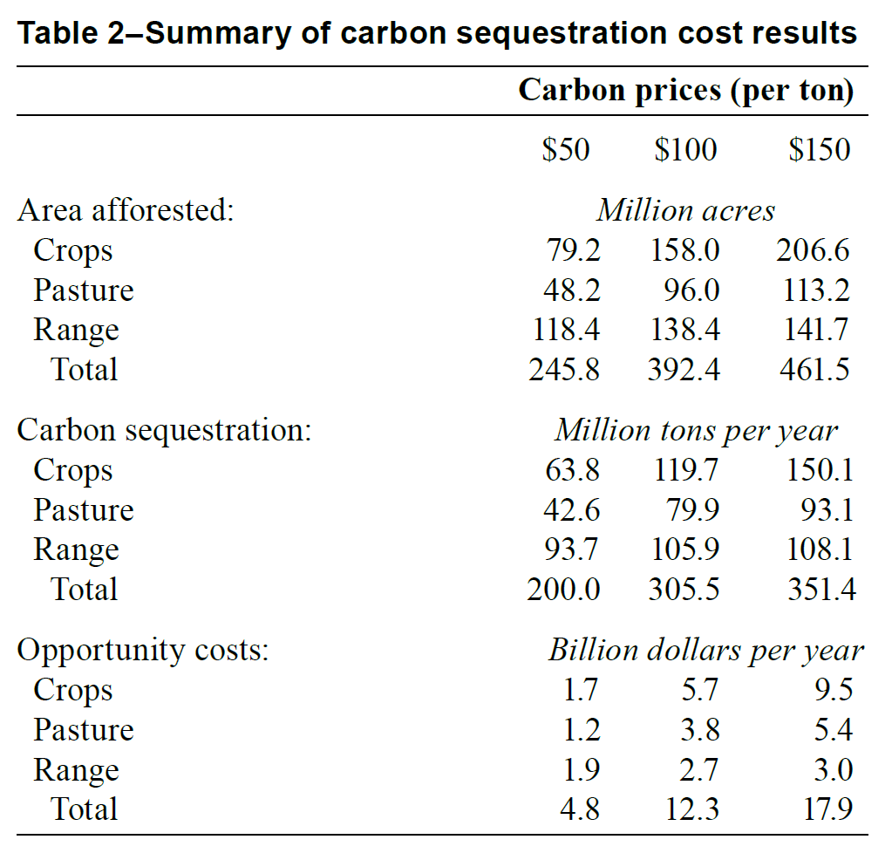

The acreage numbers there do not correspond completely to the analysis I did for the maps.

(a) The acreage numbers in Neilsen et al. (2014) are based on a carbon price in 1997 dollar terms. For this analysis I inflated the opportunity costs and land prices to 2007 dollars to be in line with some recent work, i.e. the [California 2017 Climate Change Scoping Plan](https://ww3.arb.ca.gov/cc/scopingplan/scoping_plan_2017.pdf) (see page 62). The inflated dollar terms lead to different results.

(b) The 118.4 figure assumes timber harvesting. The maps I made assume no timber harvesting, thus giving us lower afforested acres. I cannot find a record in my notes as to why we made this decision.

I can easily change the analysis to assume timber harvesting if people prefer that. I can also change the inflation terms if you feel it is necessary. I actually think it would make more sense to use more current dollars than 2007, but Andrew had suggested the 2007 mark based on that California Air Resources Board report.

Here is a summary of the acreage afforested under no timber harvesting and then assuming timber harvesting.

|  |  |  |  |  |
| --- | --- | --- | --- | --- |
|  | No periodic timber harvest | | | |
| Carbon price | Crop (ac) | Pasture (ac) | Range (ac) | Total (ac) |
| $50 | 15,362,490 | 12,773,180 | 61,205,300 | 89,340,970 |
| $20 | 143,720 | 2,783,510 | 10,350,320 | 13,277,550 |
| $12 | 94,390 | 2,193,110 | 3,339,800 | 5,627,300 |
|  |  |  |  |  |

|  |  |  |  |  |
| --- | --- | --- | --- | --- |
|  | Periodic timber harvest | | | |
| Carbon price | Crop (ac) | Pasture (ac) | Range (ac) | Total (ac) |
| $50 | 55,180,210 | 33,579,450 | 102,746,070 | 191,505,730 |
| $20 | 18,809,210 | 11,434,250 | 37,923,990 | 68,167,450 |
| $12 | 9,345,940 | 7,566,370 | 17,259,600 | 34,171,910 |

See code at the above github link to reproduce those numbers.

In any event, the statement in the abstract is not correct. It is not correct that 118.4 million acres would be afforested in the Great Plains. The 118.4 million acres figure (from Nielsen et al. 2014) is for the whole U.S. Based on the analysis I did for the maps the Great Plains would see 36,053,240 acres afforested, assuming no period timber harvesting. That number is for MT, WY, ND, SD, NE, KS, OK, and TX.

**3. Carbon and wildfire**

One study in Global Change Biology has been getting some attention. That is [Stenzel et al. (2019)](https://onlinelibrary.wiley.com/doi/abs/10.1111/gcb.14716). They argue that in wildfires “less than 5% of mature tree biomass is actually consumed” and that conventional methods overstate the quantity of CO2 emitted in forest fires. I am not a natural scientist so I cannot assess the merits of that study. But if not much CO2 is actually released in a forest fire, would we expect a net loss of carbon from afforestation + fire?

**4. Section 2.1, paragraph 1**

Tell me if I have calculated this correctly.

Juniper stands hold 64,090 kg C/ha aboveground and 52% of total ecosystem carbon is in the soil. So that is 64,090/48*100 = 133,520.83 kg C/ha total. And soil carbon accounts for 0.52*133,520.83 = 69,430.83 kg C/ha.

Tallgrass prairie holds 1660 kg C/ha aboveground and 96% of total ecosystem carbon is in the soil. So that is 1660/4*100 = 41,500 kg C/ha total. And soil carbon is 0.96*41,500 = 39,840 kg C/ha.

By those numbers it is a net gain in carbon storage if we planted over grassland with juniper forest, even if it all burns away, since 69,430.83 > 39,840. And that assumes all of the aboveground juniper carbon is emitted into the atmosphere (i.e. disregarding Stenzel et al. 2019).

Carbon is only one piece of the broader suite of ecosystem services, but if we are going to present that argument in Section 2.1, paragraph 1 I would want the carbon accounting to be clearer.

The argument in Section 2.1, paragraph 3 is clearer, but is not specific to the Great Plains.

**4. Public school revenues**

I would echo Andrew’s comment on public school revenue.

**5. Figure 3**

Figure 3 is too small and is illegible.

**6. Typos.**

(a) Page 2, bullet point 3 should say “services.”

(b) Abstract, line 3 should say “incentivize.”

(c) Abstract, line 4 should read “under a carbon market.”

(d) Abstract re: 118.4 million acres figure, see above comment.

~~(e)~~

(f) Section 2, paragraph 1. See updated numbers in above tables.

(g) Section 2.1, paragraph 2. Broken citation link on Guo and Gifford.

(h) Section 2.1, paragraph 3. “If**~~a~~**grassland soils…”

(i) Section 2.1, paragraph 6. Broken citation link on the 1660 kg figure.

(j) Figure 3. It should be “no effect” on soil carbon, not “no affect.”

(k) Several figures need a period at the end.

(l) Section 3, paragraph 1. “… policy designed **to** mitigate”.

(m) Section 3.1, paragraph 2. “(e.g., [5]” needs a parenthesis on the end.

(o) The last sentence of Section 4 should be revised for clarity.

**Other comments**

1. I feel that the term “unwanted costs” is a normative statement. What about something more neutral such as “unintended costs”? This applies to the title, as well as Section 3, paragraph 1 and Section 3.1, paragraph 2.

2. Can we write Jacob Gellman rather than Jacob C. Gellman?